**BF[1] – Decomposition Cortland Watson**

**Type in your score here 🡪 __26__ out of 26 points possible**

1. (5 points) Ponder/Reflect Exercise – Reflect on what you have learned from this portion of the class. Examples of what you can do are: a brief outline of material covered, insights you gained from class or personal study, or items you feel that you need to follow up or work on. (3-5 sentences)
   1. This week I have learned the importance of designing the experiment to be able to collect data, rather than running an experiment and then trying to make sense of the data. By using the Basic Factorial design, we are able to see how variables come into play and effect the response that we are looking for. By using this design we are able to see how one factor controls and accounts for a response.
2. (3 Points) #6 on p. 103 in book
   1. 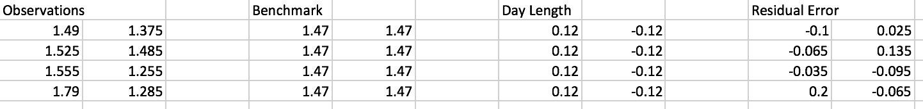
3. (3 Points) #7 on p. 103 in book
   1. long day average, overall average, observed, fitted, chance, fitted values
4. (4 points) #6 on page 103.
   1. 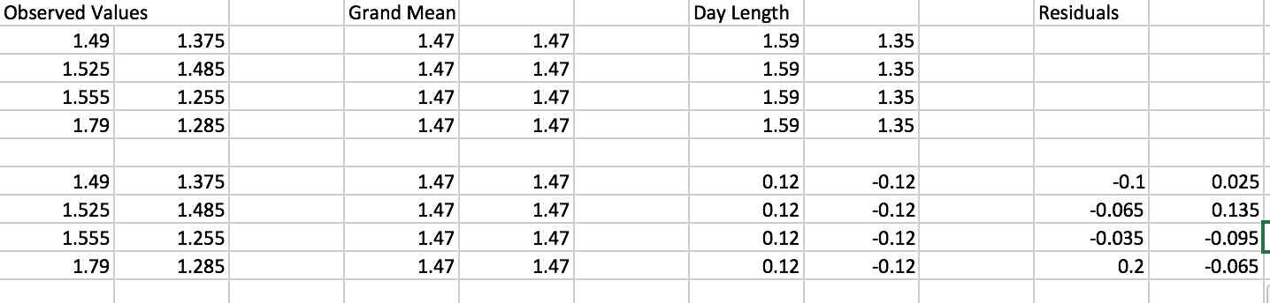
5. (5 points) #8 on p. 103. Also give a p-value for the day length factor and give a conclusion.
   1. 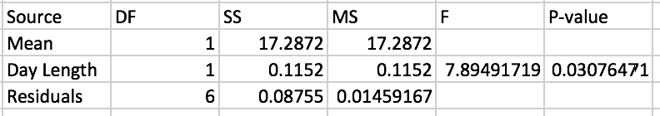
   2. Reject the null
6. (3 points) #D21 on p. 180. Instead of calculating critical values, instead use your F-statistic for “Conditions" to calculate a p-value using R.
   1. 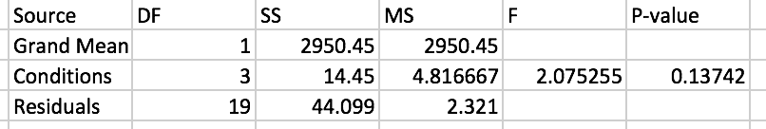
   2. 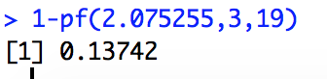
7. (3 points) #D24 on p. 181. Include an F-statistic and a p-value for the Group factor.
   1. 